**AVAILABLE NOW:**

**Rev. Meghan's newly re-released meditation CD's!**

**Special - $30 for Both!**

***The G.R.A.C.E Process - 5 Steps to Living Your Divine Self*  -** $20

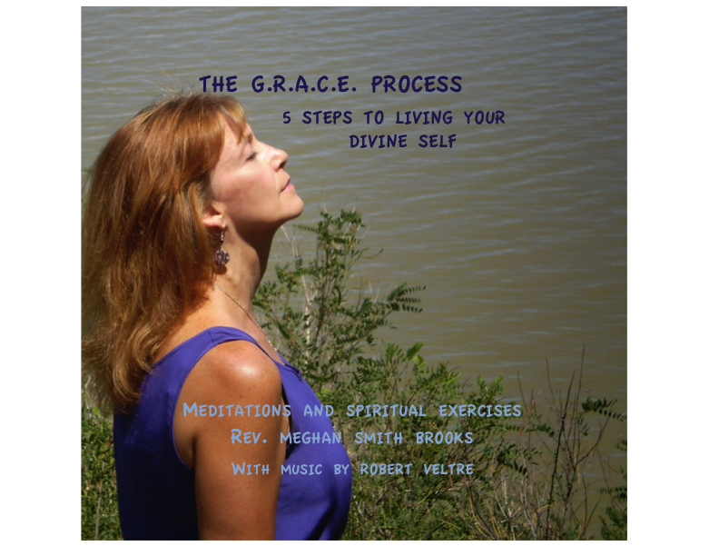

Meditation and Spiritual Exercises to transform your life - A complete workshop in one CD! Guided instruction and meditation on 7-tracks. Original music by Robert Veltre.

**MEDITATIONS FOR HEALING AND TRANSFORMATION** - $15

**Included:** A guided **Chakra Meditation**, **Rebirthing Mediation** – revision your birth and life experience, **Rose Meditation** a connection through your senses and oneness, and a **Peace meditation** to experience peace in mind, heart, body and soul - all with amazing original music by Robert Veltre

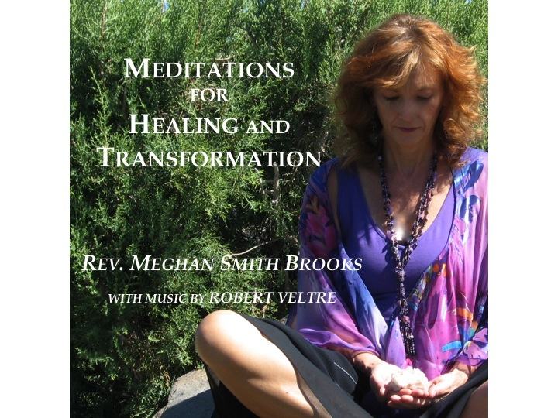

**TO ORDER EMAIL REV. MEGHAN AT**: [unityawakeningways@gmail.com](mailto:unityawakeningways@gmail.com)

And request your order. Rev. Meghan will confirm your order via email and verify your preferred method of payment.

**Shipping:** Will be shipped 3-5 days after order confirmed. $1.15 per CD added to final cost

**\*\*Credit cards** can be processed via Messenger from your Facebook account with no charge or Messenger app on your mobile phone, or Apple Pay. Send to Meghan Smith Brooks from your app $.